Lab & tool setups
Push frida in emulator
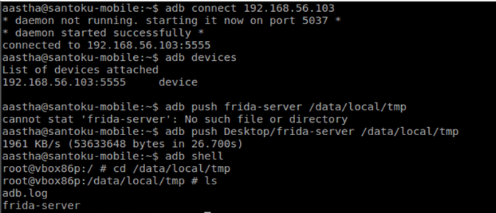
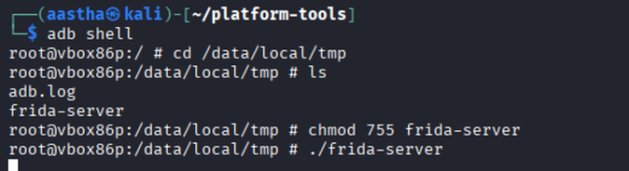

Network Intercepting
First Check the the request are intrecept on burpsuite
To do ssl pinning bypass 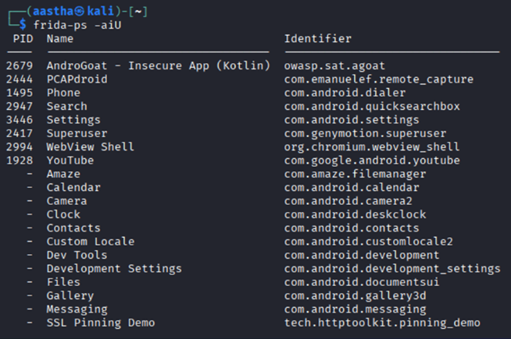

Use objection to ssl pinning bypass
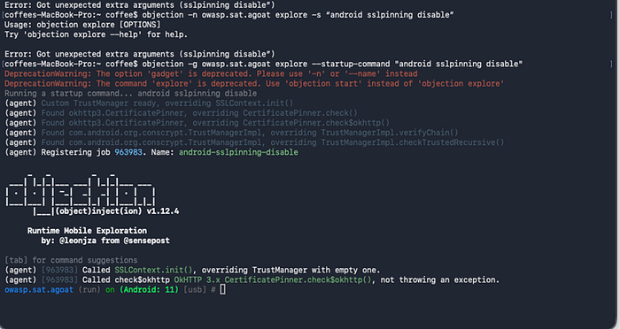
objection –n owasp.sat.agoat start –-startup-command “android sslpinning disable”

Check the OKHTTP3 its will shows on burp suite when after the ssl pinning was disable
M5: Insecure Communication

Medication is [android:exported=’false’]

Challenge 2: Unprotected Android Components
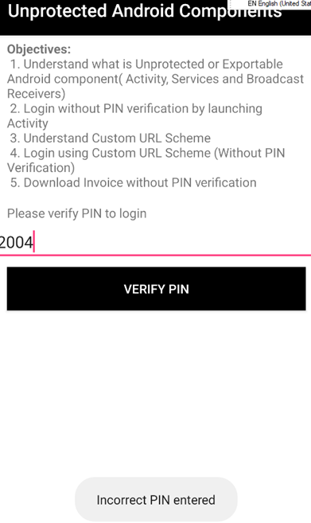
Main thing is i have to download the invoice without pin verification

First makesure with activity was use on this page (watch logcat (adb logcat | grep owasp))
Open another tab paste the activity
adb shell
am start -n owasp.sat.agoat/.AccessControl1ViewActivity
The invoice page automatically open
Mobile Top 10 M1: Improper Platform Usage.

Challenge 3: Insecure Data Storage
3.1
First mention the username and password
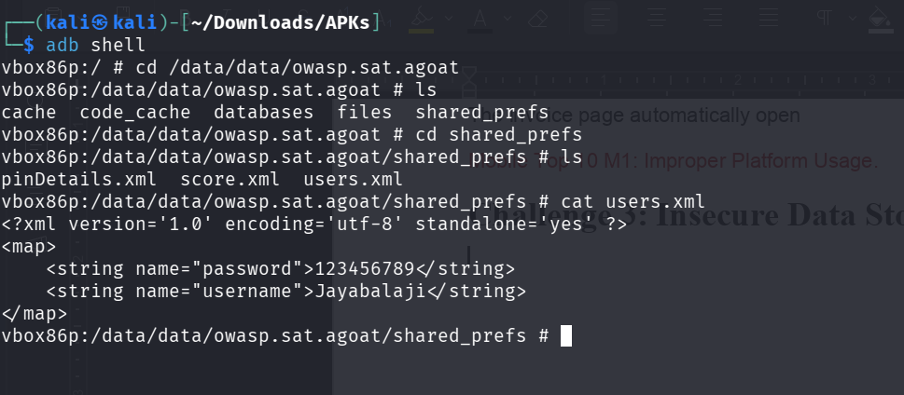

3.2 verify it

3.3 SQLite
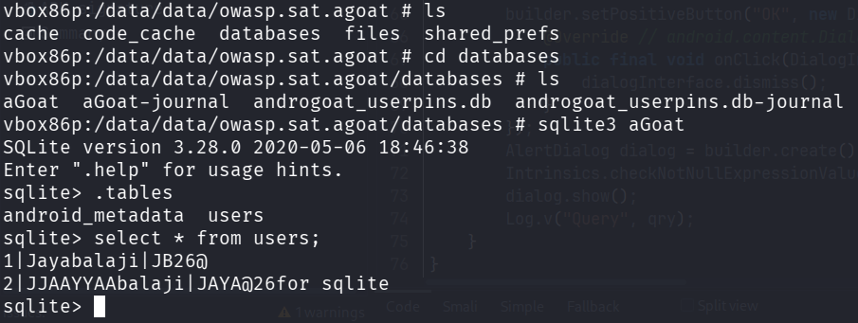
3.4 Temp File
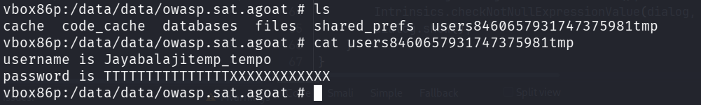

Challenge 4: Input Validation

